This is broken into three parts:
- Accessing the data
- Cleaning and polishing it
- Analyzing it

About the RAW data:
Where did we get the data?
From the Deportation Data Project. Specifically, I pulled ICE data centered around Arrests and Detention Stays. We only pulled Arrests and Detention Stays because Arrests pull a picture of how much presence of ICE has there been and Detention stays show us a picture of what is happening once someone is detained.

Why the Deportation Data Project?
It is the most reliable source out there. It is made up of legal advisors, researchers, and professors.
From their about page: The Deportation Data Project collects and posts public, anonymized U.S. government immigration enforcement datasets. We use the Freedom of Information Act to gather datasets directly from the government, and we also post datasets that the government has posted proactively or in response to others’ requests. We expect these datasets to be used by journalists, researchers, lawyers, and policymakers.
Stories published using this data include:
- The Colorado Sun: ICE arrested more than 3,500 people in Colorado in 2025 — including babies and the elderly
- Oregon Public Broadcasting: ICE detainees being transferred more often, flown farther

Accessing the data:
I downloaded data from their Processed ICE data, only ICE Arrests and ICE Detention Stays, downloaded from this page: https://deportationdata.org/data/processed/ice.html

Python Extractions:
I pulled the downloaded data (RAW ARRESTS AND RAW DETENTION STAYS) it into a Python Notebook.
- Why? This dataset included large rows of data of arrests and detention stays THROUGHOUT THE COUNTRY. If brought into Excel, it will crash or be clunky.

Python Notebook 1: ICE arrests extraction 06-26-26.ipynb
- In this notebook, I first asked the computer to show me the full RAW ARRESTS dataset
- Then I wrote code asking it to give me a dataset that includes all apprehensions between 01/01/2025 to 12/31/2025 that happened in New York State.
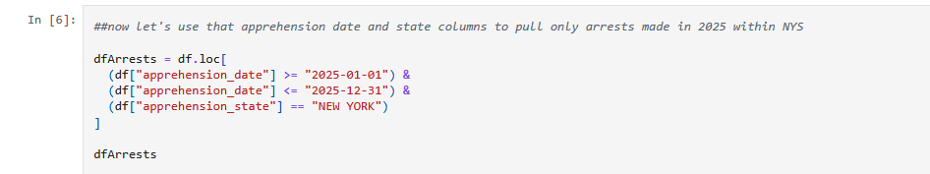
- I then downloaded that new dataset, 2025NYArrests, into my computer.
- Then, I asked the computer to look at that new dataset again and only give me a csv file, 2025NYArrests_UniqueIdentifiers with all the unique identifiers inside 2025NYArrests.
  - Why? Unique Identifiers work as a form of identifier, it’s a social security number of sorts. I pulled unique identifiers of 2025NYArrests specifically because that list of identifiers is how we are going to pull data about those detained after being arrested in NYS.
  - We cannot parse the Detention File with the same code presented up top. Someone detained in NYS might not have been detained in NYS. So, if we were to run through the same filter on the Detention File, it will not provide an accurate picture, for the analysis WE want to do for our story. Remember: We want to see how people arrested and then first detained IN NYS are moved around.
We now have downloaded:
- 2025NYArrests: All NYS arrests made by ICE in 2025
- 2025NYArrests_UniqueIdentifiers: Unique Identifiers of all those arrested in NYS in 2025.

Python Notebook 2: ICE detention stays extraction 06-26-26.ipynb
- In this notebook, I used Unique Identifiers file to filter through RAW DETENTIONS to grab a dataset on detention stays of people arrested IN New York IN 2025.
- I pulled in the RAW DETENTIONS and Unique Identifiers file into the computer.
- On the RAW DETENTIONS file, I first asked the computer to give me a dataset of only those whose detainment began in 2025. (stay_book_in_date_time)
[Detainment in 2025]
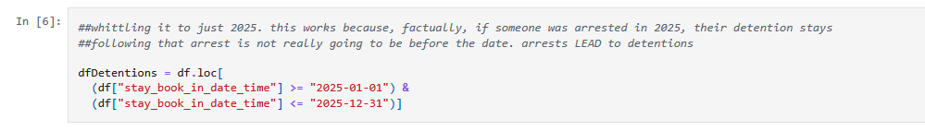
- Then using the Unique Identifiers file, I told the computer to run this list of Unique Identifiers against the Unique Identifiers column in the new dataset, Detainment in 2025 ands only give me a dataset with rows where the unique identifiers were a match.
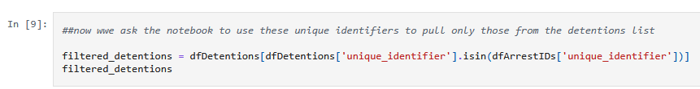

- This gave me my last file: 2025DetentionsofNYArrests

Now we have the two main files we will be taking into Excel.
- 2025NYArrests: All NYS arrests made by ICE in 2025
- 2025DetentionsofNYArrests: All detention stays of those arrested in NYS in 2025.

Cleaning the data:
Now that the dataset file is smaller and more manageable, we can clean it in Excel.
2025NYArrests.xlsx
- Inside this workbook, I made a new worksheet with the RAW Data pasted. I called this new worksheet Cleaned Data. In it I:
  - Removed State: it’s all one state, NYS
  - Removed Apprehension Type: Too many blanks
  - Cleaned up Apprehension Date by turning it into a short date. Ex: Changed 2025-01-0210:05:00 to 2025-01-02
- Dataset that we will use to analyze arrests: Cleaned Data sheet in 2025NYArrests.xlsx

2025DetentionsofNYArrests.xlsx
- Inside this workbook, I made a new worksheet with the RAW Data pasted. I called this new worksheet Cleaned Data. In it I:
  - Turned Stay Book In Date Time into just Stay Book In Date.
  - Removed columns that were too vague, too empty, or unnecessary: Religion, Marital Status, Ethnicity, Entry Status, Known Terrorist, Operating Gang, Bonded Out, MSC related columns, Felon, Entry Date, Book In, and Book Out.
  - I made a column for age by doing the math. (2025 subtract Birth Year Column)

- After cleaning, I did the following filters to the Cleaned Data Worksheet and copied the filtered results into new worksheet called, “1 stay all of NYS” In it, I:
  - Filtered only for one stay. (Multiple stays become hard to account for and confusing, we are looking for people who have been detained only once because it narrows down the possibility of doing bad math)
  - Filtered “First Detention Facility” to only spit out facilities that are IN NYS. I did this because it makes it easier for us to track the trajectory of folks that are in our coverage area. If we had to track someone detained outside of NYS, it’s too many factors and isn’t relevant to the story we are working on, plus invites too many unknowns. Remember: We want to see how people arrested and then first detained IN NYS are moved around.

- After filtering and getting 1 stay all of NYS, I filtered that new worksheet into a new worksheet called 1 stay only Upstate.
  - Here I filtered for all NY Detention Facilities that were NOT in NYC or Long Island. (Those areas are not in our coverage area)

- Then, I took 1 stay only Upstate and filtered it further into a new sheet called Upstate Removals and Departures.
  - Here I filtered “Stay Release Reason” for only Removals and Voluntary Departures. This lets us know for sure the person was deported/removed and not bonded out or released.
  - Removed blank rows in Stay Book Out Time: Uncertainty will mess up the math that will do to analyze this column. The blanks indicate that either this data is incomplete or the person is still in detention.
  - Removed blank rows from Departed Date: Uncertainty will mess up the math that will do to analyze this column. The blanks indicate that this data is incomplete
  - Made a column subtracting Final Order from Stay Book In Date to get the # of days someone stays in detention before getting a final order.
  - Made a column subtracting Departed Date from Stay Book In Date to get the # of days someone stays in detention before getting deported.
  - Made a column subtracting Departed Date from Final Order Date to get the # of days it takes someone to get deported after their final order is issued.

Analyzing the data:
The datasets we will now be using to analyze:
- Cleaned Data Sheet in the 2025DetentionsofNYArrests.xlsx workbook.
- Upstate Removals and Departures sheet in the 2025DetentionsofNYArrests.xlsx workbook.

Cleaned Data Sheet in the 2025DetentionsofNYArrests.xlsx workbook:
- Did a pivot table to see how many arrests were conducted each month in 2025
- Did a pivot table to break down the arrests by gender

Upstate Removals and Departures sheet in the 2025DetentionsofNYArrests.xlsx workbook.
- Did an average on stay book in time, departed date, final order issued date to find the average amount of time someone stays in detention and average amount of time they are there before a final order is issued.
- Did an average on # of stints to see, on average, how many stints one person was doing.
- Did a pivot table to see where men and women are detained the most first
- Did a pivot table to which detention facility the average younger person was being held the longest
- Mapped out outliers:
  - who had the longest # of stints and their trajectory.
  - Who stayed in detention the longest and their trajectory
  - Who stayed in detention the shortest and their trajectory
  - The youngest person detained and their trajectory
  - The oldest person detained and their trajectory

Our analysis:
In New York State
- The lowest number of arrests made in 2025 was in January; 283 arrests were made.
- The highest number of arrests made in 2025 was in December, 1450 arrests were made.
- Men were arrested in NYS more frequently than women. (9619 arrests for men and 1283 arrests for women) (CAVEAT! These numbers could be duplicated, 1283 women arrests DOES NOT mean 1283 women were arrested. Remember, somebody can be arrested MORE THAN ONCE in one year.)

In Upstate NY if they began their detention in Upstate NY:
Avg # of stints: 4
Avg # of days between detention and final order: 30
Avg # of days between final order and voluntary removals/deportation: 36
Avg # of days in detention before voluntary removals/deportation: 65

First Detention Facility | Male
Grand Total | 881
BUFFALO SPC | 407
ORANGE COUNTY JAIL | 63
MOSHANNON VALLEY PROCESSING CENTER | 31
ERO EL PASO CAMP EAST MONTANA | 24
JOE CORLEY PROCESSING CTR | 23

First Detention Facility | Female
Grand Total | 63
RICHWOOD COR CENTER | 9
SOUTH LOUISIANA ICE PROC CTR | 6
ELOY FED CTR FACILITY (CORE CIVIC) | 5
HOUSTON CONTRACT DET.FAC. | 5
SOUTH TEXAS FAM RESIDENTIAL CENTER | 4

Detention facility longest | Average of age (youngest)
LA SALLE CO REGIONAL DET. CENTER | 19
CLINTON COUNTY JAIL | 21
NIAGARA COUNTY JAIL | 22
PLYMOUTH CO COR FACILTY | 22
SOUTH TEXAS FAM RESIDENTIAL CENTER | 22.42857143

longest stint: 25 year old Romanian man that was detained for 99 days and moved around 14 different times in
9 different facilities before being deported to Romania

Shortest time spent in detention: 8-year-old Brazilian boy who was deported within 2 days of being detained. Detained Aug. 25, 2025. He had a final order out in January. Final charge: ALIEN PRESENT WITHOUT ADMISSION OR PAROLE - (PWAs)

Longest time spent in detention: 47-year-old El Salvadorean man that was detained for over a year, 396 days, before being deported. 6 stints in 6 different facilities, final charge: Aggravated Felony: 101(a)(43)(A) Murder, Rape or Sexual Abuse of a Minor

